23.60:

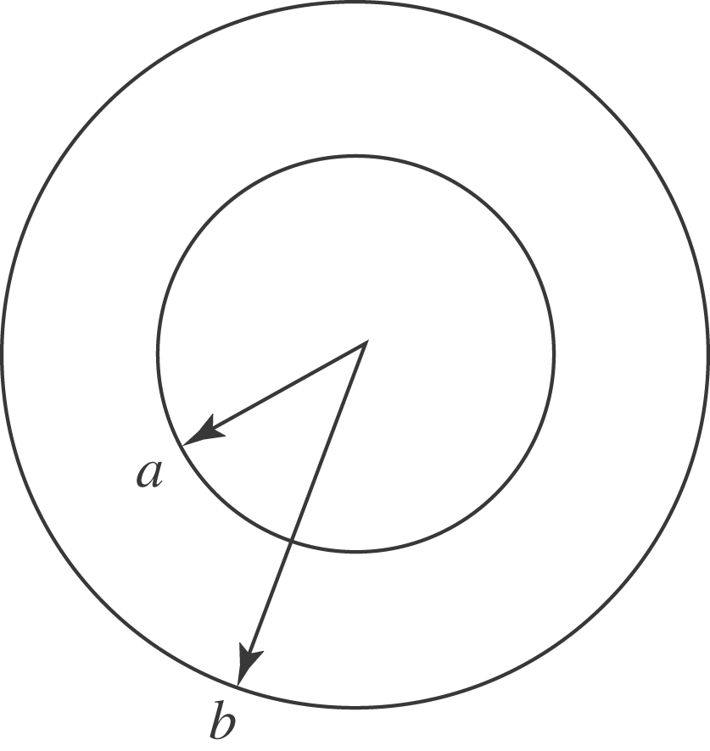
(a) Use 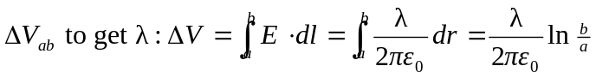
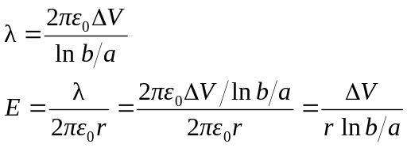

at outer surface of the wire, =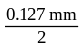
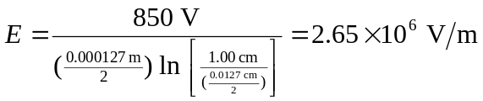
(b) at the inner surface of the cylinder, 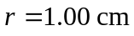, which gives
